W2 Assignment “Outcomes Planning Wheel”
Training and Development

Outcomes Planning Wheel
- Read the case study in the Week 2 lecture "How Do You D1?" (plus the list of questions at the end). As well, refer to the Planning Wheel from page 56 of the textbook. Then, write a traditional paper (see criteria below) where you discuss the four elements as they apply to the case study and use the list of questions to help guide your paper.
Template Download Here.
The requirements below must be met for your paper to be accepted and graded:
Write between 1,250 – 1,750 words (approximately 3 – 5 pages) using Microsoft Word in APA style, see example below.
Use font size 12 and 1” margins.
Include coverpage and reference page.
At least 80% of your paper must be original content/writing.
No more than 20% of your content/information may come from references.
Use at least three references from outside the course material, one reference must be from EBSCOhost. Text book, lectures, and other materials in the course may be used, but are not counted toward the three reference requirement.
Cite all reference material (data, dates, graphs, quotes, paraphrased words, values, etc.) in the paper and list on a reference page in APA style.
References must come from sources such as, scholarly journals found in EBSCOhost, CNN, online newspapers such as, The Wall Street Journal, government websites, etc. Sources such as, Wikis, Yahoo Answers, eHow, blogs, etc. are not acceptable for academic writing.
Below is the need information to write the paper:

How Do You D1?
As Steven Covey coined, “Begin with the end in mind” and that’s the long and short of D1. The define discipline is the first and probably the most important as without direction we have nothing to train nor develop. Defining business outcomes asks the question “What is the direction of the performance?” If we look back in our book, we see several figures but the idea is how to get the ROI from the training? Performance!
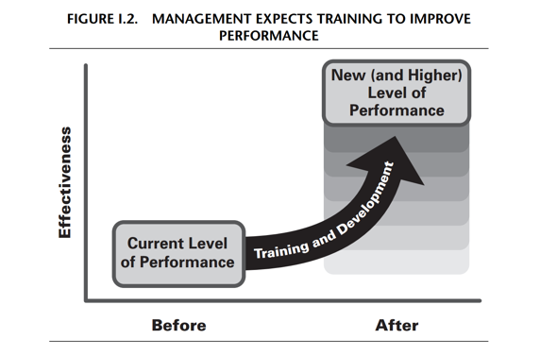
Many years ago I was a Corporate Trainer in a large organization and defining the business needs was the toughest part of the training process. Many times this required a meeting with the trainer and the business department leadership to complete a needs analysis. One of my favorite projects was the Document Manager Project.
Here is a quick real life example:
The Application Analyst (AA) department manager, Lori Williams, called the training department and asked to sit down and discuss the new product they were rolling out to all the company's AAs, worldwide, and what training could be offered starting on August 11 and ongoing as they were looking to roll out Document Manager on October 2. This product would affect 2500 people.
Lori Williams met with two trainers, Sarah Ward and Caroline Smith. Lori explained that all of the AAs were creating the same documentation over and over again, but had to save it to their own desktops and were unable to share the information because they didn't have a document repository. Document Manager was going to fix this problem. All of the AAs could then share documentation. Document Manager too would have a template in it for the AAs to use. Document Manager would make the AA's work much easier and quicker. The AAs were asked by upper management to be more effective with their documentation. Lori wanted to train all 2500 employees worldwide before Document Manger went out to the company on October 2.
Sarah and Caroline asked Lori what the AAs were using now to type up their documentation and what would be different with Document Manager. Lori explained that now AAs used Word Perfect, however Document Manager would use Microsoft Word. Due to this huge change Lori believes every employee effected needs to come to a training class that should last at least two hours, if not longer. Since the training would have to be on a computer, the training departments computer classroom's only hold 15 people per class. Lori also said that she would like to see each employee pass a test using Word and Document Manager before attaining access to the new programs. She went on to explain that she would also like to have online training for Document Manager and Word available for all employees via their intranet site. Lori also told Sarah and Caroline that upper management had not yet decided how to reach the global employees for this training. Times were tight and they didn't want to pay for the employees to travel or for Sarah and Caroline to travel. Lori said that she trusted Sarah and Caroline would have the right answer for upper management.
Lori also gave Sarah and Caroline some background on the AAs. She told them that for the most part the AA department's abilities and familiarity with computers and software was exceptional. Lori had taken over that department only two years ago, but she explained how she weeded out the non-performing employees and replaced them with hard working, smart, efficient ones. Sarah and Caroline were excited about working with this audience.
From this quick example ask yourself the following questions:
1.What organizational goal is driving this training?
2.What will the benefit be?
3.What is the skill gap?
4.What competencies (knowledge, skills, or attitudes) will this program need?
5.What evaluation will be used to measure the level of goal achievement?
6.Who will be trained?
7.What is the estimated class size?
8.How many classes will there be and how long will this training last?
9.What are the knowledge and skill prerequisites?
10.What type of program is being proposed?
11.What media, if any will be used in the training?
12.What will happen if we do not deliver the training?
13.What are the restrictions or limitations for delivering a program?
14What other methods may be used to reach the goal (include limitationsand advantages)?
Understanding the solution to the issue at hand is the goal. Gathering information from the senior management and non-supervisory employees will provide the information needed.

6Ds Outcomes Planning Wheel

1. (Goals) What business needs will be met?
2. (Behaviors) what will participants do differently & better?
3.(Measures) What or who could confirm these changes?
4.(Results) What are all the specific criteria?

